# TK3043 Tutorial 9 Greedy Algorithm

*Attempt the questions below. Then submit your answer through quiz in “Tutorial 9 all group in the UKMfolio before 2nd June 2025.*

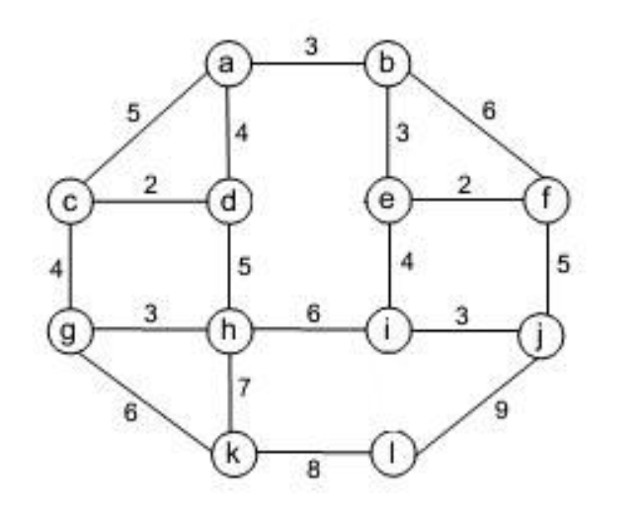

1. Apply Prim’s algorithm to the above graph. Include in the priority queue only the fringe vertices (the vertices not in the current tree which are adjacent to at least one tree vertex).

(4 marks)

2. Now, apply Kruskal's algorithm to find the minimum spanning tree (MST) for the above graph.

(6 marks)

3. Using Djikstra, find the MST using vertex ***c*** as the source for the graph below:

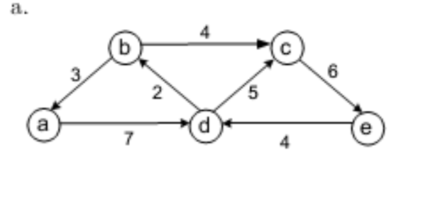

(4 marks)

4.

a) Construct a Huffman code for the data below. Prepare the frequency table and the constructed tree.

THISISHUFFMANTREEANDHUFFMANCODE

(5 marks)

b) Encode the text FREETOAD using the Huffman code of question (a).

(1 marks)

c) what is the efficiency class for Huffman?

(1 mark)

5. What is the main differences between Dijkstra with Floyd-Warshall Algo in finding shortest path? Can you find the shortest path for DAG in Question 3 with Floyds-warshall Algo?